**Dataset Used:**

File: ArSaS.txt | it contains distinct dialects and emojis and other complicated Arabic statement

Total Number of records: 21065

Total Number of contribution records: 11784

Number of negative records: 7384

Number of positive records: 4400

Number of training records: 8838 – 75% of the data

Number of evaluation records: 2946

**Model Structure:**

**Summary:**

Total params: 10,351,801 (39.49 MB)

Trainable params: 10,351,801 (39.49 MB)

Non-trainable params: 0 (0.00 B)

**Hyperparameters:**

dropout_prob = [0.5, 0.5]  
filter_sizes = [3, 5, 7]  
num_classes = 2  
nb_filter = 128  
max_features = 30000  
batch_size = 32  
epochs = 5  
  
# Initialize variables and call NN_nets_r0  
max_sent_len = 105   
embeddings_dim = 300   
nb_filter = embeddings_dim  
random_state = 0  
random.seed(0)  
np.random.seed(0)  
tf.random.set_seed(0)

**Results:**

Final Training score: 0.6209

Final Testing accuracy: 0.6266

|  |  |  |  |  |
| --- | --- | --- | --- | --- |
|  | Precision | Recall | F1-Score | Support |
| 0 | 0.63 | 1.00 | 0.77 | 1846 |
| 1 | 0.00 | 0.00 | 0.00 | 1100 |

|  |  |  |  |  |
| --- | --- | --- | --- | --- |
| Accuracy |  |  | 0.63 | 2946 |
| Macro Avg | 0.31 | 0.50 | 0.39 | 2946 |
| Weighted Avg | 0.39 | 0.63 | 0.48 | 2946 |

Training and Validation progress

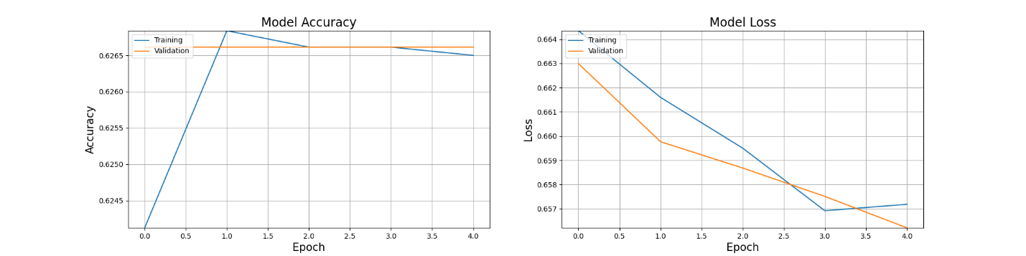

RUC Results

